**DESIGN A SIMPLE TOPOLOGY USING CISCOPACKET TRACER**

EXP NO:5B SHARMILEE B

DATE:20.8.24 231901049

**AIM:** To Design a simple topology using CiscoPacket Tracer

1. 2 SWITCHES, 8PC’s AND ONE ROUTER:

PROCEDURE:

* + TAKE 4 PC’s And assign ip address.
  + Insert a switch.
  + Connect the pc’s using copper straight through wire using fastethernet ports.
  + Implement the above steps again.
  + Implement a router
  + Now connect these two switches using gigabit ethernet.
  + Assign ip address for the gigabit ethernet and enter the ip address in the gateway of PC’s.
  + Now your topology is ready to be performed.

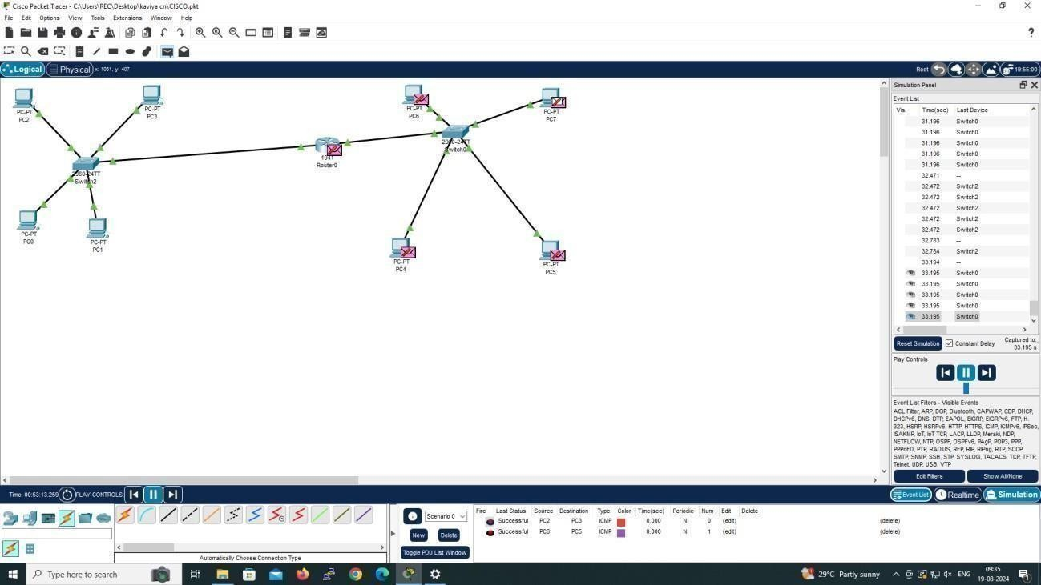

# 4 PC’s AND ONE HUB:

PROCEDURE:

* + IMPLEMENT 4 PC’s and assign ip address.
  + Insert a hub.
  + Connect the PC’s and Hub using copper straight through cables.
  + Now stimulate the message
  + Your given topology is studied successfully.

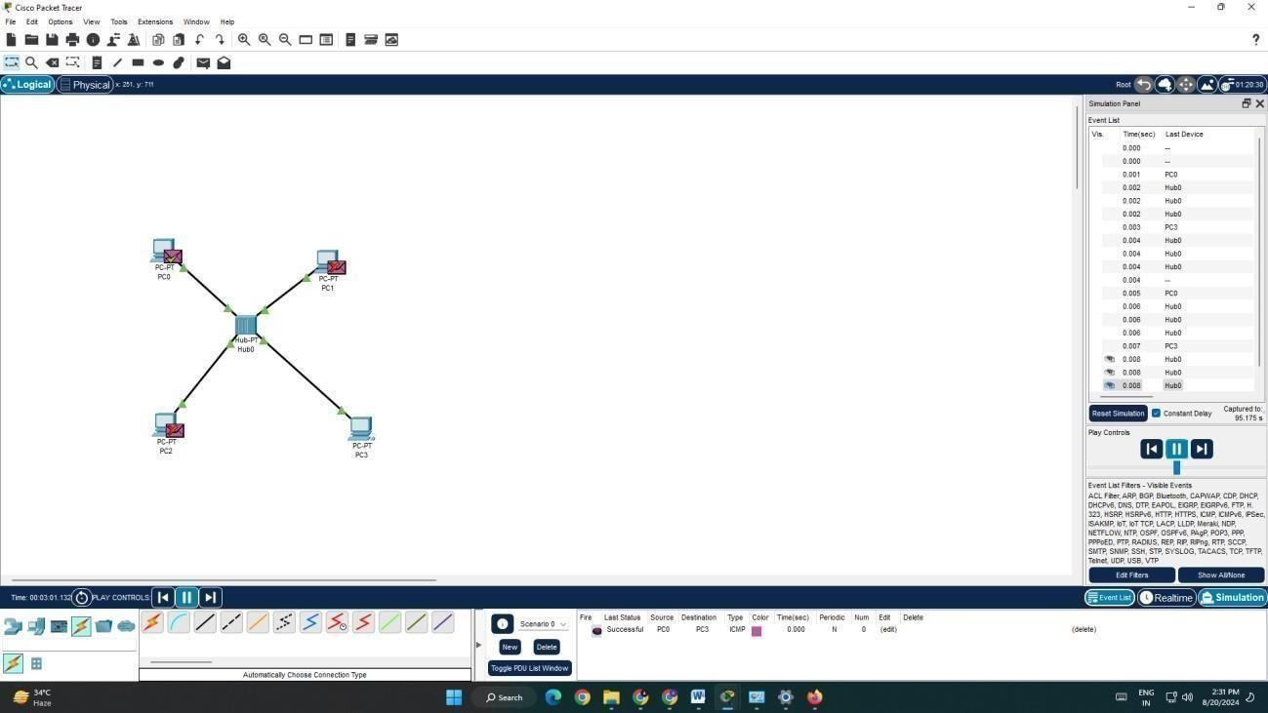

# 4 PC’s AND ONE SWITCH:

PROCEDURE:

* + IMPLEMENT 4 PC’s and assign ip address.
  + Insert a Switch.
  + Connect the PC’s and Switch using copper straight through cables.
  + Now stimulate the message.
  + Your given topology is studied successfully.

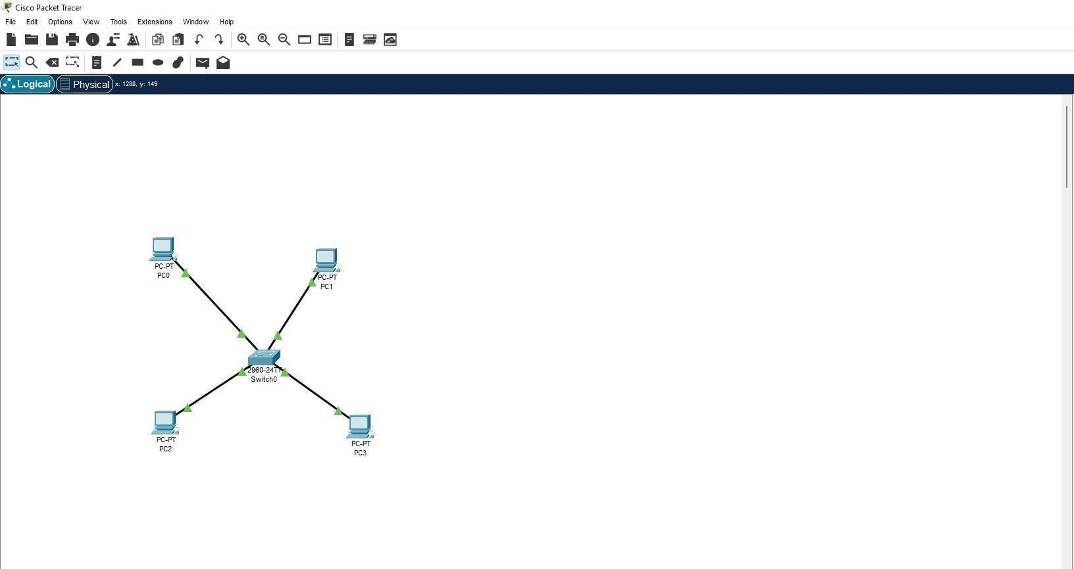

RESULT:

A simple topology using CiscoPacket Tracer is Designed successfully.